REMOVE THIS SENTENCE AND PLACE ON YOUR LETTERHEAD.
Dear Parent or Guardian:

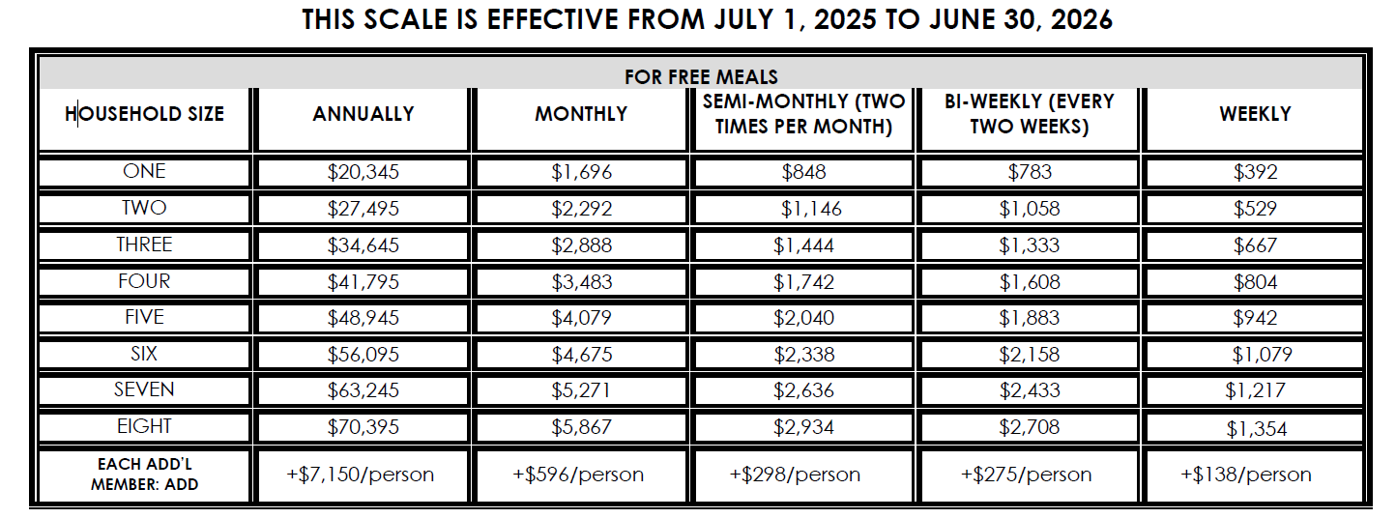
[Name of day care home] offers healthy meals and snacks to children as part of the Child and Adult Care Food Program (CACFP). Your day care provider receives support from CACFP to serve those meals. CACFP gives more support to your provider if your household income is equal to or less than the limits on this chart:

Please fill out an Enrollment/Income Eligibility Statement with all the requested information. It will help us find out how much support your provider receives. Be sure to read the instructions carefully. When you are finished, please return the form to your child care provider.

Part 1: If more than one child in your household is enrolled at this center, you only need to complete one (1) form. Please provide all of the information requested in Part 1, including the full name (as it appears on other records) of each child in your household who is enrolled at this center and each enrolled child’s date of birth. If the child is in school and attends before and/or after care at this center for most of the year, circle “YES” in the box for “Before & After Care.” Circle the day(s) when each child usually attends the center and write each child’s usual arrival and departure time. Then, circle which meal(s) each child usually receives from the center. In addition, even if you do not complete Part 2, 3, 4 or 5, you must still print and sign your name in Part 6 and provide your home address and telephone number.

Part 2: If someone in your household receives benefits from the Supplemental Nutrition Assistance Program (SNAP - formerly called Food Stamps) or from Temporary Assistance to Needy Families (TANF), complete Part 2. Write the recipient’s name, circle the type of benefit received, and provide the case number. You may circle both SNAP and TANF if the person receives both benefits. Additionally, you must complete Part 6 on the front of the form. You do not need to provide the last four digits of your social security number.

Part 3: If your child(ren) enrolled at this center participate(s) in the Head Start/Early Head Start program, complete Part 3. Write the name of each participating child in this section. In addition, you must complete Part 6 on the front of the form. You do not need to provide the last four digits of your social security number.

Part 4: If you are completing this form for a foster child who is the legal responsibility of a welfare agency or court, write the name(s) of the foster child(ren) in Part 4, then complete Part 6 on the front of the form. You do not need to provide the last four digits of your social security number if applying for foster child(ren) only. Do not complete this section if you care for a child under an informal caregiver arrangement or permanent guardianship agreement made outside of a child welfare agency or court. You may include foster children on the same form with non-foster children living in your household. Please read the form for additional instructions.

Part 5: Report current income for all household members. Skip this step if you completed Part 2 or Part 3. If the information above is not reported, the Enrollment Form/Income Eligibility Statement must contain the following information in Part 5: the names of all household members (including children enrolled at this center), the total gross income (before taxes) currently received by each household member, the frequency the amount is received, and the signature of an adult household member, and the date the form was completed. Do not include SNAP, TANF, WIC, student financial aid, or money you receive for a foster child as income. In addition, the primary wage earner or household member who signs the form must provide the last four (4) digits of his/her social security number. If there is no Social Security number, mark the Check if no SSN box.

Count the number of all children and adults in your household. Include all infants, children, students, and adults. Write the total number in the box under the list of adult household members.

USDA defines a household as a group of related or unrelated individuals (not residents of an institution or boarding house) who are living as one economic unit (i.e., sharing living expenses). Part 5 of this form must include everyone in your household.
You must report the total gross income (before taxes or deductions), listed by source, that each member of your household received during the last month. If you usually receive overtime pay, include it. If your hours or wages were recently reduced, report your current income. For each income amount reported, specify how often that income was received – weekly, every two weeks (biweekly), twice a month (semimonthly), or once a month (monthly). If last month’s income does not accurately reflect your circumstances, you may provide your usual income (with frequency) or a projection of your current annual income (specify “annual” for the frequency). You may use last year’s income as a basis for making the projection if no significant changes have occurred. If so, please specify “annual” for the frequency.

If a member of your household serves in the military, you do not need to report money received as part of the Military Housing Privatization Initiative, Family Subsistence Supplemental Allowance, Combat Pay, or Deployment Extension Incentive Pay (DEIP). If a household member is currently deployed, report only the portion of the deployed service member’s income made available to them or the household. You must include all other income and allowances when reporting gross income.

If your household’s total gross income is equal to or less than the amount indicated for your household’s size on the chart below, the center receives a higher level of federal reimbursement. Once this form is completed, the eligibility determination will be valid for 12 months. However, you should notify us if you or any other household member becomes unemployed and experiences loss of income. This period of unemployment may result in your household’s income qualifying for a different eligibility category.
Part 6: An adult household member must sign this form. The signer promises that all information is true and complete. Print the name, address, and telephone or email of the adult signer. Sign and write today’s date in the marked boxes.
In accordance with Federal civil rights law and U.S. Department of Agriculture (USDA) civil rights regulations and policies, the USDA, its Agencies, offices, and employees, and institutions participating in or administering USDA programs are prohibited from discriminating based on race, color, national origin, religion, sex, disability, age, marital status, family/parental status, income derived from a public assistance program, political beliefs, or reprisal or retaliation for prior civil rights activity, in any program or activity conducted or funded by USDA (not all bases apply to all programs). Remedies and complaint filing deadlines vary by program or incident.

Persons with disabilities who require alternative means of communication for program information (e.g., Braille, large print, audiotape, American Sign Language, etc.) should contact the responsible Agency or USDA's TARGET Center at (202) 720-2600 (voice and TTY) or contact USDA through the Federal Relay Service at (800) 877-8339. Additionally, program information may be made available in languages other than English.

To file a program discrimination complaint, complete the USDA Program Discrimination Complaint Form, AD-3027, found online at How to File a Program Discrimination Complaint and at any USDA office or write a letter addressed to USDA and provide in the letter all of the information requested in the form. To request a copy of the complaint form, call (866) 632-9992. Submit your completed form or letter to USDA by: (1) mail: U.S. Department of Agriculture, Office of the Assistant Secretary for Civil Rights, 1400 Independence Avenue, SW, Washington, D.C. 20250-9410; (2) fax: (202) 690-7442; or (3) email: program.intake@usda.gov.

USDA is an equal opportunity provider, employer, and lender.

In conjunction, the District of Columbia Human Rights Act, approved December 13, 1977 (DC Law 2-38; DC Official Code §2-1402.11(2006), as amended) prohibits discrimination on the basis of marital status, personal appearance, sexual orientation, gender identity or expression, family responsibilities, familial status, source of income, place of residence or business, genetic information, matriculation, or political affiliation of any individual. Additional protected traits can be found at https://ohr.dc.gov/protectedtraits. To file a complaint alleging discrimination on one of these bases, please contact the District of Columbia’s Office of Human Rights at (202) 727-4559 or https://ohr.dc.gov/service/file-complaint. If you require information about this program, activity, or facility in a language other than English, contact the District of Columbia Office of Human Right’s Language Access Program at (202) 727-4559.

Thank you for your cooperation.

Signature of Authorized Institution Representative

